**Mahmoud Ali Mohamad Obaid**

Mirdif- United Arab Emirates

Email: mahmoudhsbc@gmail.com

Mobile # 055 985 4685

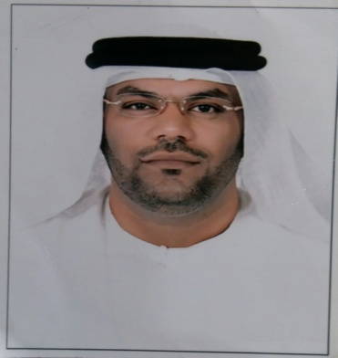

**OBJECTIVES:**

A challenging position where I can utilize my work experience, expertise and creative ability to make a positive contribution towards the growth of the organization leading to career advancement.

**CAREER OBJECTIVES**

* To attain the highest growth from within and for the organization I represent and to be the best in whatever I do and my education background and ability to work well with people are my advantage.
* Profile summary, can be able to work with multi-task on high-pressured.
* Having a friendly and engaging personality
* Excellent in computer and software skills including micro soft word.
* Excellent communication, negotiation and interpersonal skills
* Should have confident manner, Helpful and polite
* Able to work as part of a team
* Can work in multi-tasking duties, Smart appearance and articulate.

**WORK EXPERIENCE**

**Organization : HSBC Bank Corp. Dubai UAE Year June 2007 – December 2021**

Duties and Responsibilities

**Position Held : Teller**- Provides accounts services to the customers by receiving deposits and loan payments, balance currency, coins and checks in cash drawers at end of shift, and calculate daily transaction using computers, calculator or adding machine.

- Examine checks for endorsement and to verify other information such as dates, bank names, identification of the person, receiving payments and the legality of the documents,

- Enter customer transaction into computers in order to record transaction and issue computer-generated receipts.

**-**Resolve problems or discrepancies concerning customer account receive and counts daily inventories of cash, process and maintain records of customer loan etc.

**HSBC - Customer Service -** Assist customers with routine accounts-related request such: fund transfer, automatic funds transfer. Helping customers about bank deposit products and service charges, inquiries about ATM and debit card usage and limits.

-Research and resolve customer problems, Verify information on ATM/debit card application to the information in customer database. Contact customer to notify them that the checks orders and/or debit cards are ready to pick up at the bank.

**HSBC - Receptionist -** Greeting customers with a smile and welcoming them into the bank. Managing courier, postal, ticket booking and message for the banking staff. Maintaining daily records of incoming and outgoing calls and checks.

**Organization: Etisalat Telecom Corp. Dubai Year 2002-2007**

**Position Held: Receptionist/Front Desk Office**

Duties and Responsibilities:

Serve visitors by greetings, welcoming directing and announcing them appropriately. Answer. Screen and forward any incoming phone calls while providing basic information when needed. Perform other clerical receptionist duties such as filing, photocopying, faxing etc.

**PERSONAL DATA**

Date of Birth : March 06 1976

Nationality : Emirate

Driving Lic no. : 821111

I hereby certify that the above information is true and correct best on my knowledge belief.

REFERENCE –available upon request

**__________________**

**Applicants Signature**